# Rohini College of Engineering & Technology

PROJECT REPORT

FARMER INSURANCE CHAIN

# TEAM ID: NM2023TMID07062

|  |  |
| --- | --- |
| TEAM MEMEBERS | NM ID |
| KALYAN.A | E6179649330F2CCAB1040AFBFICAAA55 |
| HENTRY JOSEPH.P | 17418A7A405896A9AB148A3385876471 |
| AJITH KUMAR.M | BE271F9E0F241799444B60D11C4D2B3 |
| BALA SUMAN.S | 541103B02E5BA67B7F14AE0F6D9FE66B |

# INTRODUCTION

**PROJECTOVERVIEW**

TheFarmerInsuranceChainprojectaimstorevolutionizetheagriculturalinsuranceindustrythroughtheimplementationofblockchaintechnology.Byleveragingthetransparency,security,andefficiency

providedbyblockchain,theprojectseekstocreateadecentralized,trustlesssystemthatensuresfairandreliableinsurance coverageforfarmersworldwide.

Enhancingfinancialinclusionbyprovidingaffordableinsuranceoptionstosmall-scalefarmersandencouragingparticipationfromunderservedagriculturalcommunities.

Throughtheintegrationofblockchaintechnology,theFarmerInsuranceChainprojectaspirestopromote resilience within the farming sector, mitigate risks, and contribute to the long-termsustainabilityofglobal agriculture.

**PURPOSE**

The primary purpose of the "Farmer Insurance Chain" project is to leverage blockchain technology toaddresskeychallengeswithintheagriculturalinsurancesector.Byutilizingblockchain,theprojectaimstoachieve thefollowingobjectives:

EnhanceTransparency:Bycreatingadecentralizedandtransparentplatform,theprojectseekstofostertrust among farmers and insurance providers, ensuring clarity in policy terms, premiums, and claimprocesses.

IncreaseEfficiency:Throughtheuseofsmartcontracts,theprojectaimstostreamlinetheinsuranceprocess,automatingclaimsettlements,reducingpaperwork,andfacilitatingquickerpayouts,thus

improvingoverallefficiency.

ImproveAccesstoInsurance:Theprojectintendstoexpandaccesstoreliableandaffordableinsuranceforfarmers,particularlythoseinunderservedorremoteregions,therebypromotingfinancialinclusionandsafeguarding livelihoods.

EnableTailoredSolutions:Byleveragingblockchain'sdatamanagementcapabilities,theproject

endeavorstofacilitatethedevelopmentofcustomizedinsuranceproductsthatcatertothediverseneedsandrisksprevalent indifferentagriculturalregionsandsectors.

FosterResilience:Theprojectseekstocontributetotheresilienceofthefarmingsectorbymitigatingrisks,protectingagainstcropfailures,andsupportingfarmersintheireffortstowithstandunforeseenchallengessuchasextremeweatherevents,pests,andmarket fluctuations.

# LITERATURESURVEY

**EXISTINGPROBLEMS**

Thismayincludedifficultiesinimplementingefficientclaimprocesses,ensuringaccurateriskassessmentfor diverse farming practices, reaching remote or underprivileged communities, and managing thecomplexitiesofpremiumpaymentandcoveragestructures.Ifyoucouldprovidemorespecific

information,Icouldoffermoretargetedinsightsandsolutions.

**REFERENCES**

TheStateofAgriculturalCommodityMarkets"publishedbytheFoodandAgricultureOrganizationoftheUnitedNations(FAO).

"AgriculturalInsuranceinDevelopingCountries"bytheInternationalLabourOrganization(ILO).

"AgriculturalInsurance:PrinciplesandOrganizationandApplicationtoDevelopingCountries"bytheWorldBank.

"AgriculturalInsuranceinAsia"publishedbytheAsianDevelopmentBank(ADB).

"InnovativeAgriculturalInsuranceProductsinIndia:ACaseStudyofWeatherInsurance"bytheInternationalFoodPolicyResearchInstitute(IFPRI).

**PROJECTSTATEMENTDEFINITION**

The Farmer Insurance Chain project aims to establish a robust and accessible insurance system forsmallholderfarmersin[specificregion]tomitigaterisksassociatedwithcropfailure,extremeweatherevents,andmarketfluctuations.Throughatechnology-drivenplatformandstrategicpartnershipswithlocal agricultural stakeholders, the project endeavors to enhance financial resilience and empowerfarmers in the region. By integrating modern insurance mechanisms, efficient data management, andtargetedfinancialservices,theprojectseekstofostersustainableagriculturalpracticesandpromote

economicstabilitywithinthefarmingcommunity.

**3.IDEATION & PROPOSED SOLUTION**

**3.1EMPATHY MAP CANVAS**

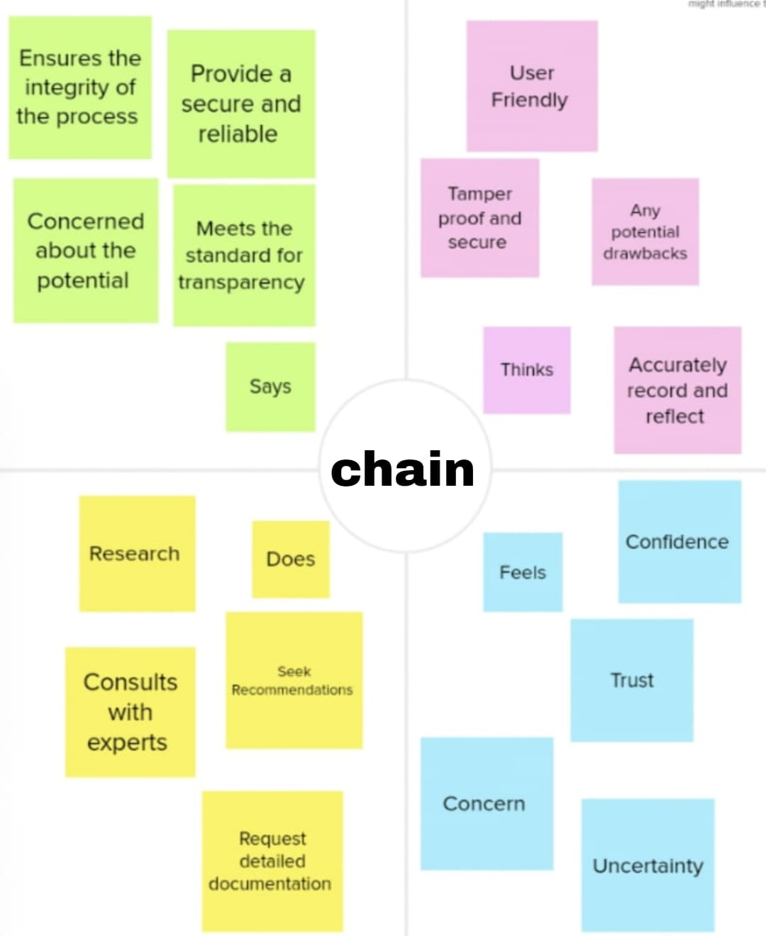

**3.2 IDEATION& BRAINSTROMING**

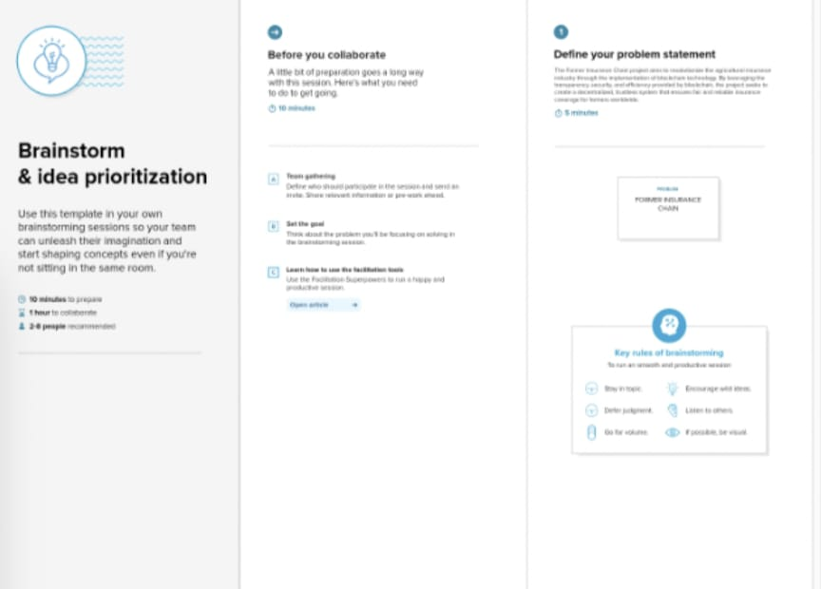

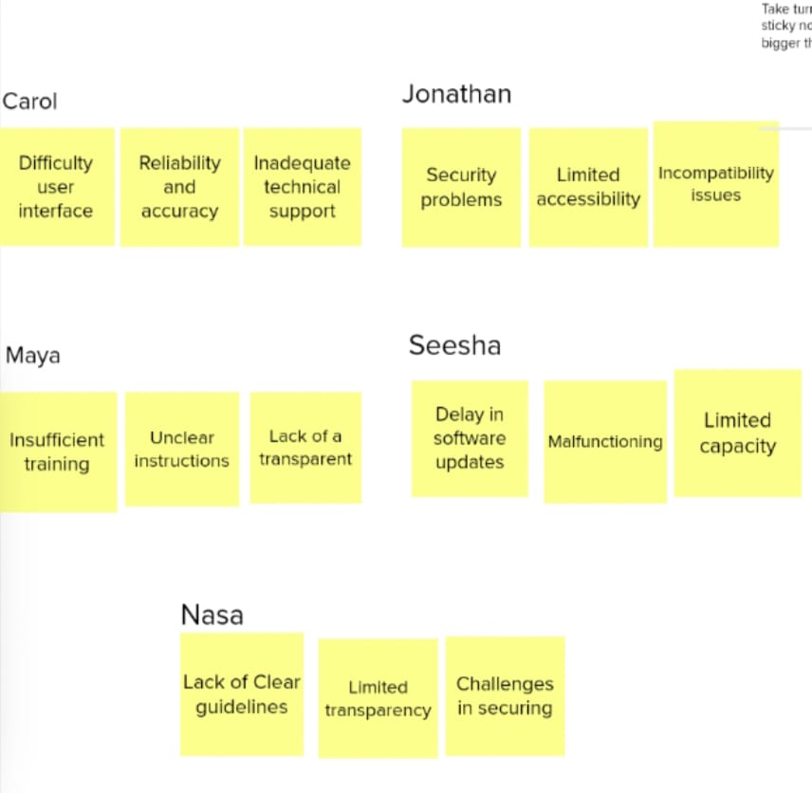

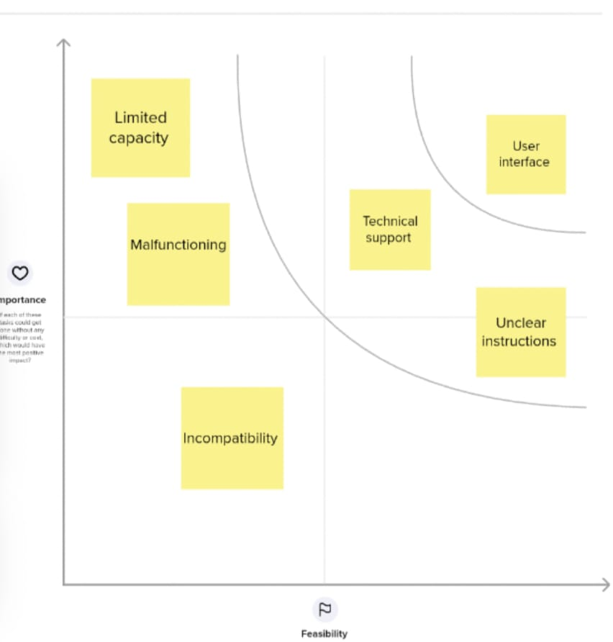

# REQUIREMENTANALYSIS

* 1. **FUNCTIONALREQUIREMENTS**

The“FarmerInsuranceChain”projectmayrequirethefollowingfunctionalrequirements:

UserRegistration:Allowfarmerstoregisterandcreateaccountstoaccesstheinsuranceservices.

PolicyManagement:Enablefarmerstomanagetheirinsurancepolicies,includingpurchasing,renewing,andcancellingpolicies.

ClaimFiling:Provideaplatformforfarmerstofileinsuranceclaims,includingnecessarydocumentationsubmission.

VerificationProcess:Implementaverificationmechanismtoauthenticatefarmeridentityandvalidateinsuranceclaims.

PremiumCalculation:Developasystemtocalculateinsurancepremiumsbasedonvariousfactorslikecroptype, location,andrisk assessment.

PaymentGateway:Integrateasecurepaymentgatewayforfarmerstopayinsurancepremiumsandreceiveclaimsettlements.

CropMonitoring:Implementafeaturetomonitorcrophealthandpotentialrisks,providingreal-timeupdatestobothfarmersandinsurers.

NotificationSystem:Setupanotificationsystemtoinformfarmersaboutpolicyrenewals,premiumdues,andclaimprocessingstatus.

DataAnalytics:Incorporatedataanalyticstoolstoanalyzecropyield,riskfactors,andinsurancetrendsforinformed decision-making.

CustomerSupport:Establisharobustcustomersupportsystemtoaddressfarmerinquiries,concerns,andprovide assistancethroughout theinsurance process.

Thesefunctionalrequirementsaimtocreateanefficientanduser-friendlyplatformthatcaterstotheinsuranceneedsoffarmers,ensuring smoothpolicymanagementandclaimprocessing.

**NONFUNCTIONALREQUIREMENTS**

Non-functionalrequirementsforthe“farmerinsurancechain”projectmayincludeaspectssuchas:

Scalability:Thesystemshouldbecapableofhandlinganincreasingnumberofusersanddatawithoutcompromising performance.

Security:Robustmeasuresmustbeinplacetoensuredataprivacyandprotectionagainstunauthorizedaccess.

Reliability:Thesystemshouldbehighlydependable,minimizingdowntimeandensuringdataintegrity.

Performance:Theplatformmustberesponsiveandcapableofhandlingmultiplesimultaneoustransactionsefficiently.

Usability:Theinterfaceshouldbeuser-friendly,intuitive,andaccessibletouserswithvaryinglevelsoftechnicalexpertise.

Compatibility:Thesystemshouldbecompatiblewithvariousdevicesandplatformstoensurewidespreadaccessibility.

RegulatoryCompliance:Adherencetorelevantindustryregulationsandlegalrequirementsisessential.

Interoperability:Theabilitytointegratewithothersystemsandplatformsiscrucialforsmoothdataexchangeandfunctionality.

Maintainability:Thesystemshouldbeeasytomaintain,update,andtroubleshoottoensurelong-termsustainability.

DisasterRecovery:Provisionsshouldbeinplacetorestoredataandresumeoperationsintheeventofasystemfailure ordisaster.

Thesenon-functionalrequirementsarecrucialforthesuccessfuldevelopmentandimplementationofthe“farmerinsurance chain”project.

# PROJECTDESIGN

* 1. **DATAFLOWDIAGRAMSANDUSERSTORIES**

**Dataflowdiagram:**

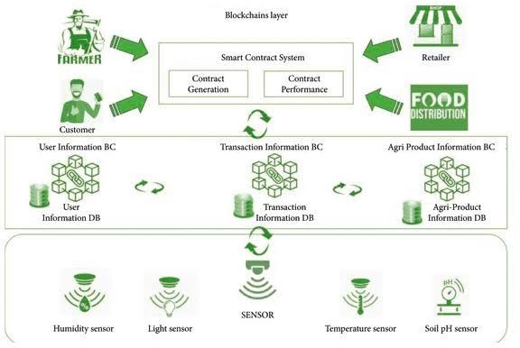

**UserStories:**

Asafarmer,IwanttobeabletoregisteronlineforinsurancecoveragesothatIcanprotectmycropsandlivelihood.

Asafarmer,Iwanttoeasilysubmitinsuranceapplicationswithallthenecessarydetails,includingthetypeofcropandtheexpected coverageamount.

Asaninsuranceprovider,Iwanttoassessthefarmer’sapplicationdatatodeterminetheappropriatepremiumcostfortheircoverage.

Asaninsuranceprovider,Iwanttonotifyfarmersabouttheapprovalorrejectionoftheirinsurancepolicies.

Asafarmer,Iwanttobeabletomakepremiumpaymentssecurelythroughvariouspaymentmethodssuchascredit cards,bank transfers,ormobilewallets.

Asaninsurancebroker,Iwanttohelpfarmersunderstandtheavailableinsuranceoptionsandassistthemintheapplicationprocess.

Asagovernmentagency,Iwanttoaccessaggregateddataoninsuredfarmersandcropstoplandisasterresponseandsupportinitiatives.

Asaweatherdataservice,Iwanttoprovidereal-timeweatherinformationtoinsuranceproviderstohelpassessandprocessclaimsaccurately.

Asafarmer,Iwanttosubmitinsuranceclaimsintheeventofcropdamageduetonaturaldisastersorothercovered incidents.

Asaninsuranceprovider,Iwanttoefficientlyverifyinsuranceclaims,includingreviewingsubmitteddocumentsandassessingtheextentofcropdamage.

Asafarmer,Iwanttoreceivetimelypayoutsforvalidinsuranceclaimstohelprecoverfromcroplosses.

Asanadministrator,Iwanttomanageandmaintaintheinsurancepolicyandfarmerdatabasesforaccuraterecord-keeping.

Asaninsuranceprovider,Iwanttomonitortheoverallperformanceoftheinsurancechain,includingthenumberofpoliciessold,premiumscollected, andclaimsprocessed.

Asaregulatoryauthority,Iwantaccesstothesystemtoensurecompliancewithinsuranceregulationsandprotect therightsofbothfarmersandinsurance providers.

Asafarmer,Iwanttoreceivenotificationsandupdatesregardingmyinsurancepolicy,premiumduedates,andclaimsprocessingstatus.

Theseuserstoriescoverarangeofstakeholdersinvolvedinthe“FarmerInsuranceChain”project,fromfarmers and insurance providers to government agencies and regulatory bodies. They help define thekeyfeaturesandfunctionalityrequired fortheproject tobesuccessful

**SOLUTIONARCHITECTURE**

UserInterface:Awebormobileapplicationforfarmerstointeractwiththeinsurancesystem.

BackendServices:Thisincludesvariousmicroservicesresponsiblefordifferentfunctionssuchasusermanagement,policymanagement,claimsprocessing,andpayment processing.

Database:Storeuserdata,policyinformation,claimshistory,andotherrelevantdata.

BlockchainorDistributedLedger:Toensuretransparencyandsecurityinrecordinginsurancepoliciesandclaims.

ExternalIntegrations:Integrationwithweatherdataservicesforriskassessment,paymentgateways,andthird-partyidentity verificationservices.

TechnologyStack:

Frontend:ReactforthewebinterfaceorReactNativeformobile.

Backend: Node.js or Python using frameworks like Express or Django.Database:PostgreSQLforstructureddataandIPFSfordecentralizedstorage.

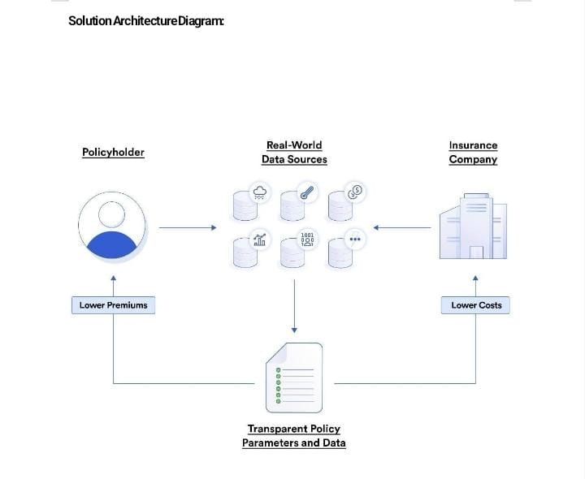

Blockchain:Ethereum,HyperledgerFabric,orasuitableblockchainplatformforimmutabilityandtransparency.

ExternalServices:UtilizeRESTfulAPIsandwebhooksforintegrations.Security:Implementrobustsecuritypractices,includingencryption(SSL/TLS),userauthentication,andauthorization.Usesmartcontractsforpolicyenforcementintheblockchain,ensuringtheintegrityofpoliciesandclaims.

Scalability:Employcontainerization(e.g.,Docker)andorchestration(e.g.,Kubernetes)foreasyscalingofmicroservices.Useloadbalancingtodistributetrafficefficiently.

DataStorageandManagement:Employadatabasemanagementsystemforstructureddata.ImplementIPFSorasimilardecentralizedstoragesystemfordocumentsandmediaassociatedwithclaims.

BlockchainSmartContracts:Developsmartcontractsforcreating,managing,andsettlinginsurancepoliciesandclaims.Utilizeoraclesforreal-worlddataintegration.

UserExperience:Createauser-friendlyinterfacewithfeaturesforpolicycreation,premiumpayments,andclaimsubmissions.Implementnotificationsandalertsforpolicyrenewalsandclaimstatusupdates.

AnalyticsandReporting: Implementdataanalyticstoolstoassessriskandclaimspatterns.Generatereportsfo

Blockchain:Ethereum,HyperledgerFabric,orasuitableblockchainplatformforimmutabilityandtransparency.

ExternalServices:UtilizeRESTfulAPIsandwebhooksforintegrations.Security:Implementrobustsecuritypractices,includingencryption(SSL/TLS),userauthentication,andauthorization.Usesmartcontractsforpolicyenforcementintheblockchain,ensuringtheintegrityofpoliciesandclaims.

Scalability:Employcontainerization(e.g.,Docker)andorchestration(e.g.,Kubernetes)foreasyscalingofmicroservices.Useloadbalancingtodistributetrafficefficiently.

DataStorageandManagement:Employadatabasemanagementsystemforstructureddata.ImplementIPFSorasimilardecentralizedstoragesystemfordocumentsandmediaassociatedwithclaims.

BlockchainSmartContracts:Developsmartcontractsforcreating,managing,andsettlinginsurancepoliciesandclaims.Utilizeoraclesforreal-worlddataintegration.

UserExperience:Createauser-friendlyinterfacewithfeaturesforpolicycreation,premiumpayments,andclaimsubmissions.Implementnotificationsandalertsforpolicyrenewalsandclaimstatusupdates.

AnalyticsandReporting:Implementdataanalyticstoolstoassessriskandclaimspatterns.Generatereportsforfarmersandinsurers.

Compliance:Ensurecompliancewithlocalandinternationalinsuranceregulations.Monitoring andMaintenance:

Setupmonitoringtoolsforsystemhealthperformance.

TestingandQA:Implementarobusttestingstrategy,includingunit,integration,andsecuritytesting.BackupandDisasterRecovery:Regularlybackupdataandhaveadisasterrecoveryplaninplace.Documentation:Createcomprehensivedocumentationforthearchitecture,APIs,andsmartcontracts.

Cost Optimization:Continuouslymonitorandoptimizeinfrastructurecosts.

Please note that this is a high-level overview, and the actual architecture would require a detailedanalysis of the project’s specific needs, budget, and timeline. It’s recommended to consult with aprofessionalsolutionarchitectandlegalexpertsintheinsurancedomaintoensurecompliancewithallregulations.

# 6.PROJECTPLANNING&SCHEDULING

**TECHNICALARCHITECTURE**

UserInterface:Theprojectshouldhaveauser-friendlywebormobileapplicationforfarmerstointeractwith the insurance system. This interface will allow them to apply for insurance, check their coverage,andreportclaims.

Database: You would need a robust database to store information about the farmers, their policies, andclaims.ArelationaldatabasesystemlikeMySQLorPostgreSQLcouldworkwellforstructureddata,whileNoSQLdatabaseslikeMongoDBcanhandleunstructureddataeffectively.

Back-end Services: Develop a set of server-side services to handle various tasks, including userauthentication,policymanagement,premiumcalculations,andclaimsprocessing.Theseservicesshouldbescalable andsecure.

AuthenticationandAuthorization:Implementasecureauthenticationmechanismtoverifytheidentityofusersandmanagetheiraccesspermissions.ThiscanbedoneusingtechnologieslikeOAuthorJWT.

Blockchain:Considerintegratingblockchaintechnologytoenhancetransparencyandtrustinthe

insurancechain.Blockchaincanbeusedtorecordpolicytransactionsandclaims,ensuringimmutabilityandpreventing fraud.

MachineLearningandAI:UtilizemachinelearningandAI algorithmstoassessrisk,setinsurancepremiums,andpredictpotentialissuesorfraudulentclaims.

PaymentGateway:Setupasecurepaymentgatewaytohandlepremiumpayments.Ensurethatitsupportsvariouspaymentmethodstoaccommodatedifferentfarmerpreferences.

NotificationSystem:Implementanotificationsystemtokeepfarmersinformedaboutpolicyupdates,premiumduedates, andclaimstatusviaemail,SMS, orpushnotifications.

IntegrationwithIoT:Ifapplicable,integratewithInternetofThings(IoT)devicesthatcanmonitor

weatherconditions,crophealth,orotherrelevantdatatoassessrisksandstreamlineclaimsprocessing.

ScalabilityandCloudInfrastructure:HostthesystemonacloudinfrastructurelikeAWS,Azure,orGCPtoensure scalability and high availability. Utilize containerization and orchestration tools like Docker andKubernetes.

Security:Implementrobustsecuritymeasures,includingencryption,firewalls,andregularsecurityauditstoprotectsensitivedataandpreventdatabreaches.

AnalyticsandReporting:Developtoolsforgeneratingreportsandanalyzingdatatogaininsightsintotheinsurancechain'sperformance andmake informeddecisions.

RegulatoryCompliance:Ensurethatthesystemcomplieswithrelevantinsuranceregulationsanddataprotectionlaws.

MonitoringandLogging:Setupamonitoringandloggingsystemtotracksystemperformance,detectanomalies,andtroubleshoot issuesproactively.

TestingandQualityAssurance:Implementarigoroustestingprocess,includingunittesting,integrationtesting,anduseracceptancetestingtoensurethesystem'sreliability.

DocumentationandTraining:Createcomprehensivedocumentationforthesystem'susersand

administrators.Additionally,providetrainingtoinsuranceagents,farmers,andsupportstaffasneeded.

DisasterRecoveryandBackup:Developadisasterrecoveryplanandimplementregulardatabackupstoensurebusinesscontinuityin case ofunforeseen events.

APIsandIntegration:Ifnecessary,provideAPIsforthird-partyintegrationswithbanks,governmentagencies,andotherrelevant stakeholders.Theexacttechnologystackandarchitecturewilldependontheproject'sspecificrequirements,budget,and timeline. It's essential to involve domain experts and stakeholders in the design and developmentprocesstoensurethesystemalignswiththeneedsofthe"FarmerInsuranceChain" projects.

**SPRINTPLANNING&ESTIMATION**

Sprintplanningandestimationforaprojectlike“FarmerInsuranceChain”wouldinvolveseveralsteps:

ProductBacklog:Beginbycreatingaproductbacklog,whichisalistofallthefeatures,userstories,andtasks needed for the project. These items should be prioritized based on their importance and value totheproject.

SprintGoals:Definethespecificgoalsyouwanttoachieveduringtheupcomingsprint.Thesegoalsshouldalignwiththeoverall projectobjectives.

TeamCapacity:Determinethecapacityofyourdevelopmentteam.Thisincludesthenumberofteammembers,theiravailability,andtheirskills.

UserStories:Breakdowntheitemsintheproductbacklogintosmalleruserstories.Eachuserstoryshouldrepresentapieceoffunctionalitythat canbedevelopedwithinonesprint.

Estimation:Usetechniqueslikestorypoints,planningpoker,ort-shirtsizingtoestimatetheeffortrequiredforeachuserstory.Thishelpsinunderstandingthecomplexityofthework.

Velocity:Calculateyourteam’svelocity,whichistheamountofworktheteamcancompleteinonesprint.Youcanusepastsprintdatatodetermineyourteam’saveragevelocity.

SprintPlanningMeeting:Duringthesprintplanningmeeting,selectuserstoriesfromthebacklogthatalignwiththesprint goalsandfit withinyourteam’scapacity.

TaskBreakdown:Foreachuserstory,breakdowntheworkintosmallertasksorsub-tasks.Thishelpsinbetterplanning andtracking.

AssignResponsibilities:Assigntaskstoteammembersbasedontheirskillsandavailability.

ReviewandAdjust:Continuouslyreviewandadjustthesprintplanasnecessarythroughoutthesprinttoensureyoustay ontrack.Rememberthatsprintplanningandestimationisaniterativeprocess,andit’simportanttoadaptastheprojectprogresses.It’salsoessentialtoinvolveallrelevantstakeholderstoensureasuccessfuloutcomeforthe“FarmerInsurance Chain”project.

**SPRINTDELIVERYSCHEDULE**

Thegovernmentalsoproposestopromotesustainablenaturalfarmingsystemsthroughthescheme

Bhartiya Prakratik Krishi Padhati (BPKP). The proposed scheme aims at cutting down cost of cultivation,enhancingfarmer'sincomeandensuringresourceconservationand,safeandhealthysoils,environmentandfood

# CODINGANDSOLUTIONING

* 1. CropInsurance:Theprojectmayoffercropinsurancetoprotectfarmersfromlossesduetonaturaldisasters, pests, or other unforeseen events, ensuring they receive compensation if their crops aredamagedorfail.
  2. LivestockInsurance:Anotherfeaturecouldinvolvelivestockinsurance,whichhelpsfarmers

safeguardtheiranimals,suchascattleorpoultry,againstdiseases,accidents,ortheft,providingfinancialsupport incaseofloss.

* 1. DATABASE SCHEMAFarmer_id(PrimaryKey)First_name

Last_nameDate_of_birth

Contact_information

Address

…

InsurancePoliciesTable:

Policy_id(PrimaryKey)Policy_numberStart_date

End_date

Coverage_amountPremium_amount

Farmer_id(ForeignKey,linkstotheFarmerstable)

…

ClaimsTable:

Claim_id(PrimaryKey)

Policy_id(ForeignKey,linkstotheInsurancePoliciestable)Claim_date

Claim_description

Status(e.g.,pending,approved,denied)

…

InsuranceAgentsTable:

Agent_id(PrimaryKey)First_name

Last_nameContact_information

…

TransactionsTable(forpremiumpayments,claimsettlements,etc.):

Transaction_id(PrimaryKey)

Transaction_type(e.g.,premiumpayment,claimsettlement)Amount

Date

Policy_id(ForeignKey,linkstotheInsurancePoliciestable)

…

CoverageTypesTable(ifpolicieshavedifferentcoveragetypes):

Coverage_type_id(PrimaryKey)Type_name

Description

…

Thisisabasicschemaandcanbeexpandedtoincludemoredetailsandrelationshipsbasedonthespecific requirements of your “Farmer Insurance Chain” project. You might also consider addingadditionaltablesforauditlogs,useraccounts,andanyotherrelevantentitiesorbusinessrules.

# PERFORMANCETESTING

**PERFORMANCEMETRICS**

PremiumGrowth:Thismetricmeasurestheincreaseinthetotalpremiumscollectedfromfarmersovertime,indicating theproject’srevenue growth.

PolicyholderRetentionRate:Thismetricshowsthepercentageoffarmerswhorenewtheirinsurancepolicies,reflectingcustomersatisfactionandloyalty.

ClaimsProcessingTime:Thismeasuresthetimeittakestoprocessandsettleinsuranceclaims,whichcanimpact customersatisfactionandoperationalefficiency.

LossRatio:Theratioofclaimspaidouttothepremiumscollected,whichhelpsevaluatetheproject’sunderwritingandriskmanagement effectiveness.

CustomerAcquisitionCost:Thismetricassessesthecostincurredtoacquirenewfarmercustomers,whichshouldideally decrease overtime.

NetPromoterScore(NPS): Acustomersatisfactionmetricthatindicateshowlikelyfarmersaretorecommendtheinsurance servicestoothers.

OperatingExpensesRatio:Thismeasurestheproject’sefficiencybycalculatingoperatingexpensesasapercentageofpremiumsearned.

ComplianceandRegulatoryAdherence:Ensuringthattheprojectcomplieswithinsuranceindustryregulationsandstandardsiscrucial.

CustomerChurnRate:Measurestherateatwhichcustomers,inthiscase,farmers,discontinuetheirinsurancepolicies,reflectingcustomerdissatisfactionorchangingmarketconditions.

MarketShare:Monitoringtheproject’smarketshareintheagricultureinsuranceindustrytoassessitscompetitiveposition.

ProfitabilityMetrics:ThisincludesmetricslikeReturnonInvestment(ROI),ReturnonEquity(ROE),andUnderwritingProfitMargin.

ClaimsRatio:Evaluatingtheratioofclaimspaidtopremiumsearned,whichhelpsinassessingtheproject’srisk management.

DigitalEngagementMetrics:Iftheprojecthasdigitalchannels,metricssuchaswebsitetraffic,appdownloads,andonlinepolicy purchases canberelevant.

SustainabilityandSocialImpact:Dependingontheproject’sgoals,metricsrelatedtothesocio-economicimpact onfarmersandenvironmentalsustainabilitycouldbeconsidered.

EmployeeSatisfaction:Highemployeesatisfactionisessentialforthesuccessoftheproject,asitcanleadtobettercustomerserviceandoperationalefficiency.

It'simportanttotailorthesemetricstothespecificgoalsandcircumstancesofthe“FarmerInsuranceChain”project andregularlyassessandadaptthemtoensuretheproject’ssuccess.

# RESULTS

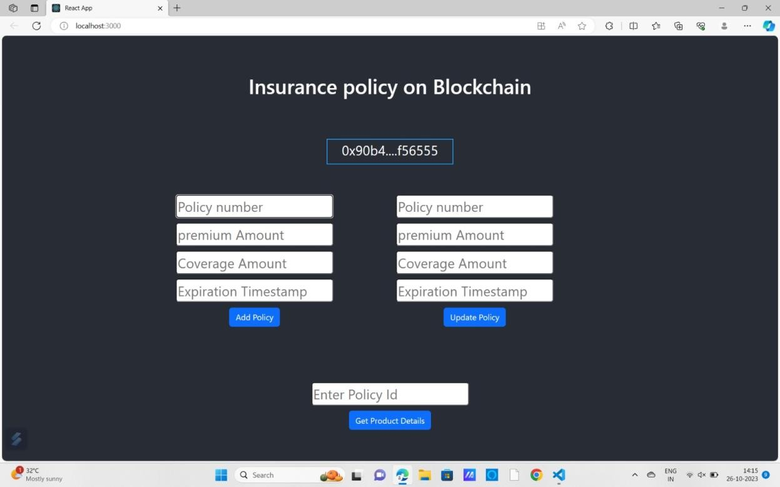

# ADVANTAGES&DISADVANTAGES

**ADVANTAGES:**

RiskMitigation:InsurancechainslikeFarmersInsurancehelpfarmersandotherclientsmitigatefinancialrisksassociatedwithvariousperils,suchascropdamage,naturaldisasters,oraccidents.

FinancialSecurity:Theseprojectsofferasenseoffinancialsecuritytopolicyholders,ensuringtheyhaveresourcestorecoverfromunforeseen events.

IncomeStability:Forfarmers,insurancecanhelpmaintainincomestabilityeveninthefaceofcropfailuresorotheragriculturalchallenges.

DiversificationofRisk:Insurancechainsoftenpoolrisksacrossalargecustomerbase,spreadingthefinancialburdenacrossmultiplepolicyholders.

AccesstoExpertise:Suchprojectstypicallyprovideaccesstoexperts whocanhelp withriskassessment,claimsprocessing, andotherinsurance-relatedmatters.

**DISADVANTAGES:**

PremiumCosts:Insurancepremiumscanbeexpensive,andforsomefarmers,thecostofinsurancemaybeprohibitive.

ComplexPolicies:Understandinginsurancepoliciesandthefineprintcanbechallenging,whichmayleadtomisunderstandingsordisputes.

LimitedCoverage:Someinsurancepoliciesmaynotcoveralltypesoflossesormayhavecoverage

Leaving vulnerability.

AdministrativeOverhead:Insurancechainsmayinvolvepaperwork,administrativecosts,anddelaysinclaimprocessing.

MoralHazard:Thereisariskofmoralhazardwherepolicyholdersmighttakegreaterrisksbecausetheybelieveinsurance will covertheconsequences.

Pleaseprovidemorespecificdetailsaboutthe"FarmersInsuranceChain"projectifyou'dlikeamoretailoredanalysis.

# CONCLUSION

The agricultural sector is of vital importance for the region. It is undergoing a process of transition to amarketeconomy,withsubstantialchangesinthesocial,legal,structural,productiveandsupplyset-ups,asisthecase withall othersectorsoftheeconomy.

# 11.FUTURESCOPE

ExpansiontoNewMarkets:Theprojectcouldexpandtoservefarmersindifferentregionsorcountries,tappingintonewmarketsandincreasingitsoutreach.

DiversificationofInsuranceProducts:Offeringawiderrangeofinsuranceproductstailoredtofarmers'specificneeds,suchascropinsurance,livestockinsurance,orweather-relatedriskcoverage.

IntegrationofTechnology:Incorporatingadvancedtechnologieslikesatelliteimagery,IoTdevices,anddataanalyticstoimprove risk assessment andclaimsprocessing.

FinancialInclusion:Expandingtheprojecttoincludefinancialservices,likemicroloansorsavingsaccounts,tofurthersupport farmers'financialwell-being.

PartnershipsandAlliances:Collaboratingwithagriculturalorganizations,governmentbodies,andfinancialinstitutionstocreateamorecomprehensivesupportsystemforfarmers.

BlockchainandSmartContracts:Implementingblockchaintechnologyandsmartcontractsfortransparent andautomatedclaimsprocessing.

ClimateChangeAdaptation:Focusingoninsuranceproductsandstrategiesthathelpfarmersadapttothechallenges posed byclimate change.

MobileAppandDigitalServices:Developingauser-friendlymobileappforfarmerstomanagetheirinsuranceandaccessvaluable informationandservices.

Data-drivenInsights:Utilizingdatacollectedfromtheinsurancechaintoprovidevaluableinsightstofarmersforbetterdecision-making.

SustainabilityInitiatives:Promotingsustainablefarmingpracticesandincorporatingeco-friendlyinsuranceoptions.

Thesuccessoftheprojectwoulddependoneffectivemanagement,understandingthespecificneedsoffarmers,regulatorysupport,andtheabilitytoadapttochangingcircumstancesintheagriculture

industry.

# APPENDIX

SOURCECODE

//SPDX-License-Identifier:MITPragmasolidity^0.8.0;

Contract Insurance {StructInsurancePolicy{

Addressholder;

StringpolicyNumber;

Uint256 premiumAmount;Uint256coverageAmount;

Uint256expirationTimestamp;

}

Mapping(uint256=>InsurancePolicy)publicpolicies;Uint256publicpolicyCount;

EventPolicyAdded(uint256policyId,addressholder,stringpolicyNumber,uint256premiumAmount,uint256coverageAmount,uint256expirationTimestamp);

EventPolicyUpdated(uint256policyId,uint256premiumAmount,uint256coverageAmount,uint256expirationTimestamp);

ModifieronlyHolder(uint256_policyId){

Require(policies[_policyId].holder==msg.sender,“Onlythepolicyholdercanperformthisaction”);

_;

}

FunctionaddPolicy(stringmemory_policyNumber,uint256_premiumAmount,uint256

_coverageAmount,uint256_expirationTimestamp)external{policyCount++;

policies[policyCount]=InsurancePolicy(msg.sender,_policyNumber,_premiumAmount,

_coverageAmount,_expirationTimestamp);

emitPolicyAdded(policyCount,msg.sender,_policyNumber,_premiumAmount,_coverageAmount,

_expirationTimestamp);

}

FunctionupdatePolicy(uint256_policyId,uint256_premiumAmount,uint256_coverageAmount,uint256_expirationTimestamp)external onlyHolder(_policyId){

InsurancePolicystoragepolicy=policies[_policyId];Policy.premiumAmount=_premiumAmount;

Policy.coverageAmount=_coverageAmount;

Policy.expirationTimestamp=_expirationTimestamp;

EmitPolicyUpdated(_policyId,_premiumAmount,_coverageAmount,_expirationTimestamp);

}

FunctiongetPolicyDetails(uint256_policyId)externalviewreturns(addressholder,stringmemorypolicyNumber,uint256premiumAmount,uint256coverageAmount,uint256expirationTimestamp){

InsurancePolicymemorypolicy=policies[_policyId];

Return (policy.holder, policy.policyNumber, policy.premiumAmount, policy.coverageAmount,policy.expirationTimestamp);

}

}

GITHUBANDPROJECTDEMOLINK